Name: Mrunali Katta
ID : 017516785
DATA 226 - HOMEWORK 1

- Created a Snowflake account.
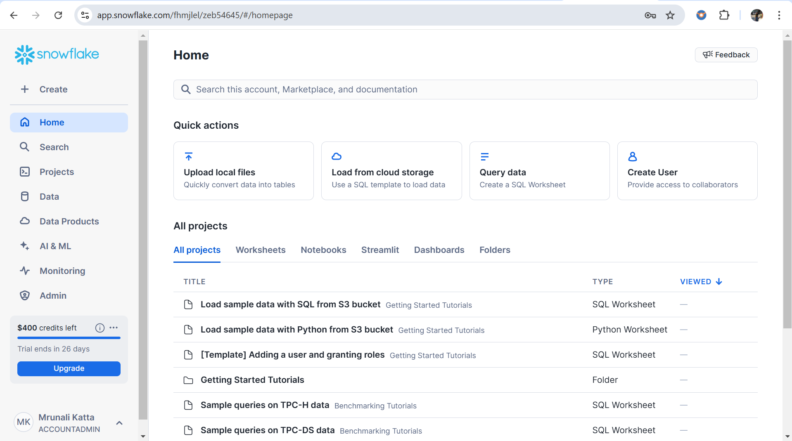

- Created a Database 'car_sales_db', Schema 'car_sales_schema', Table 'car_sales_tbl'
using the default warehouse “COMPUTE_WH” of size XSMALL.
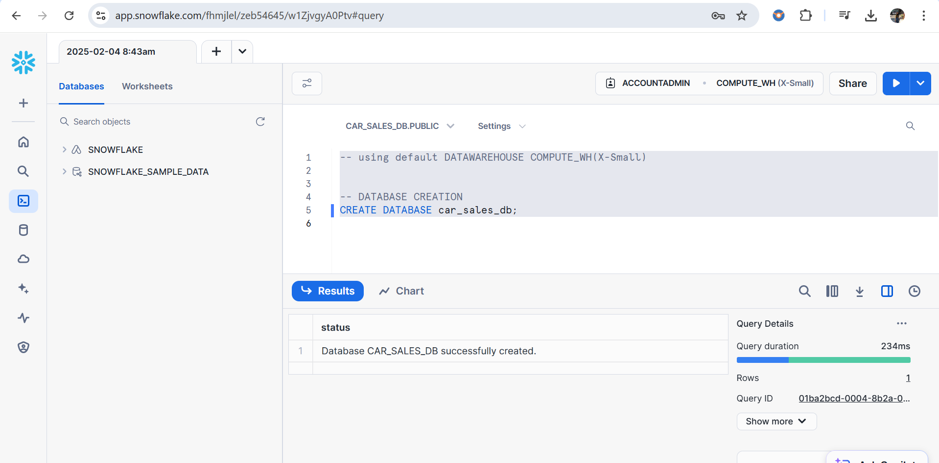
CODE:
CREATE DATABASE car_sales_db;
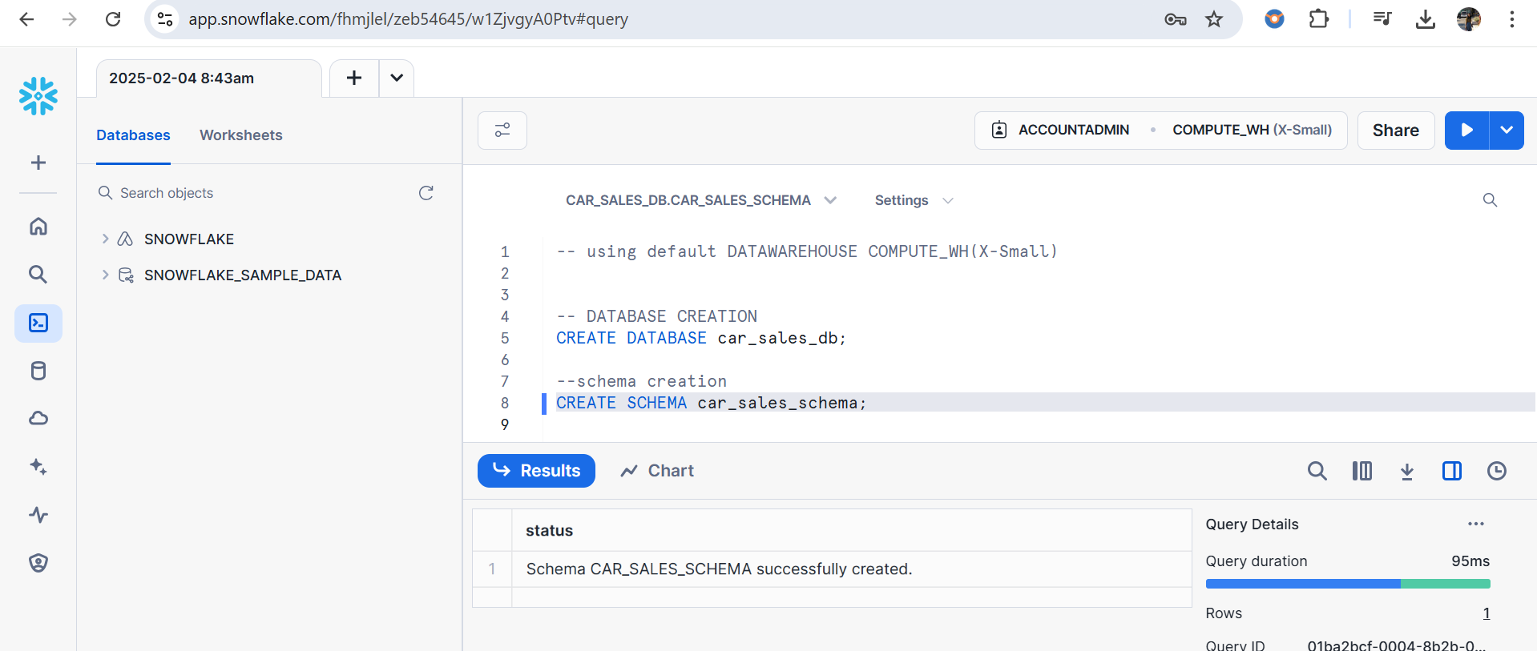
CODE:
CREATE SCHEMA car_sales_schema;

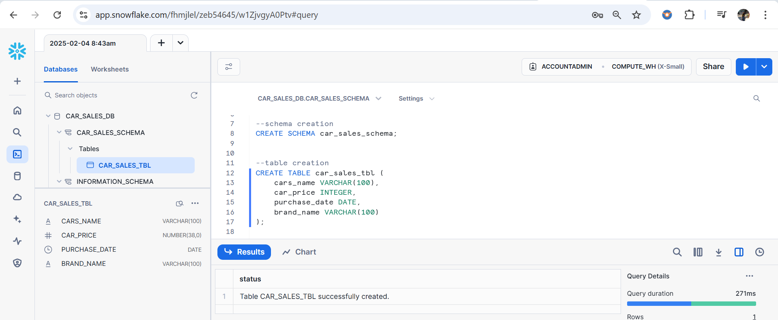
CODE:
CREATE TABLE car_sales_tbl (
cars_name VARCHAR(100),
car_price INTEGER,
purchase_date DATE,
brand_name VARCHAR(100)
);

- Stage creation Created a stage 'car_sales_stage' in Snowflake and load the csv.
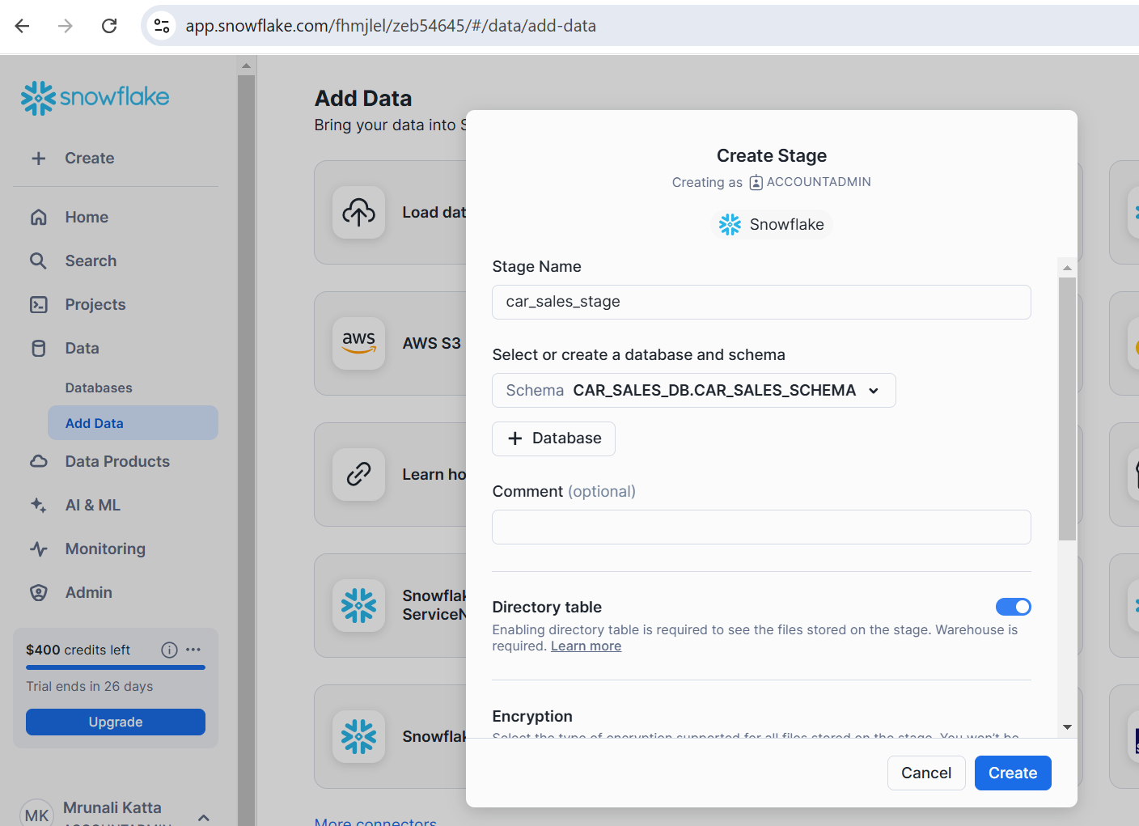
Loaded the Car_Sales_Data.csv file into the earlier created stage ‘car_sales_stage’
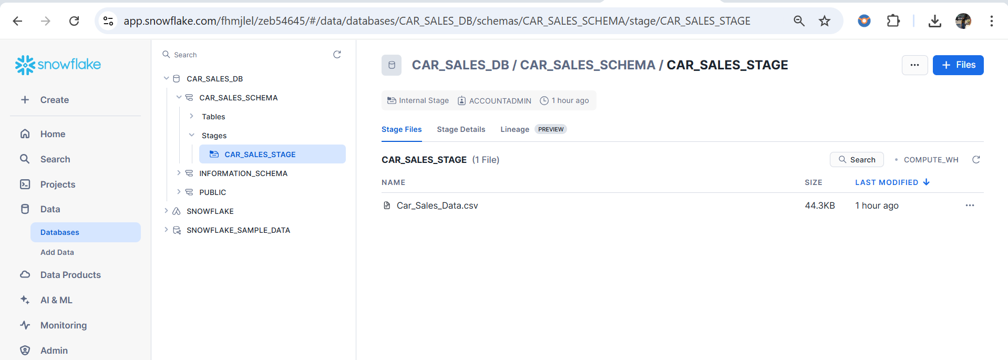

4. Created a file format called ‘car_sales_format’ and Loaded Data into the 'car_sales_tbl' table using COPY INTO query.
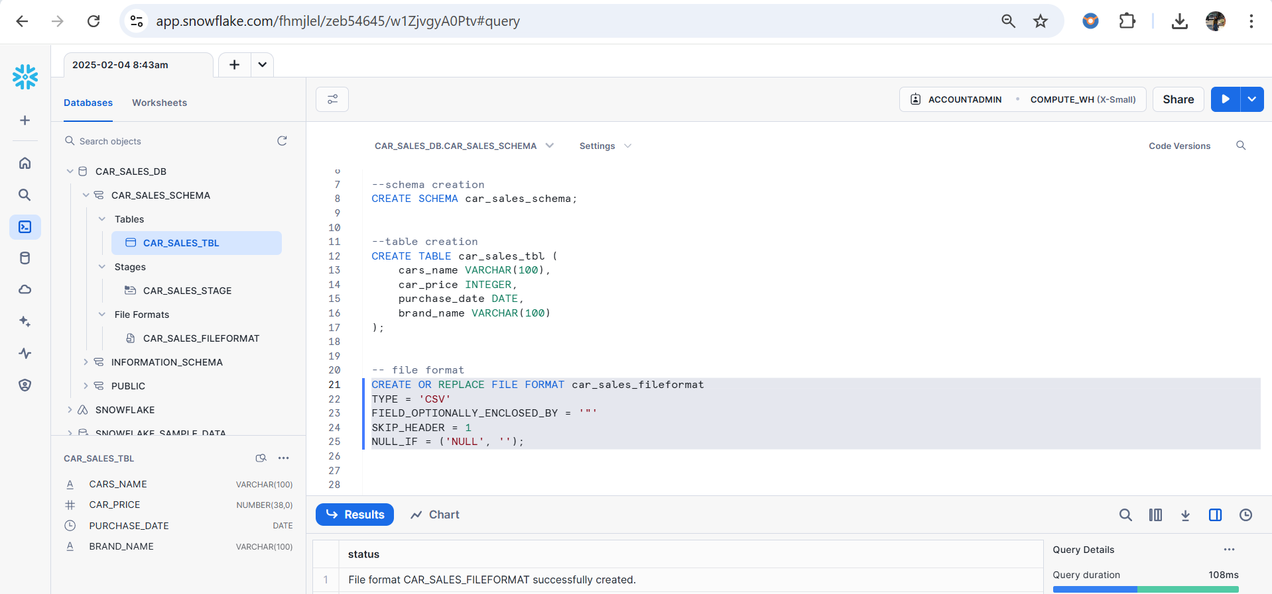
CODE:
CREATE OR REPLACE FILE FORMAT car_sales_fileformat
TYPE = 'CSV'
FIELD_OPTIONALLY_ENCLOSED_BY = '"'
SKIP_HEADER = 1
NULL_IF = ('NULL', '');

Now loaded data into the 'car_sales_tbl' table using COPY INTO query
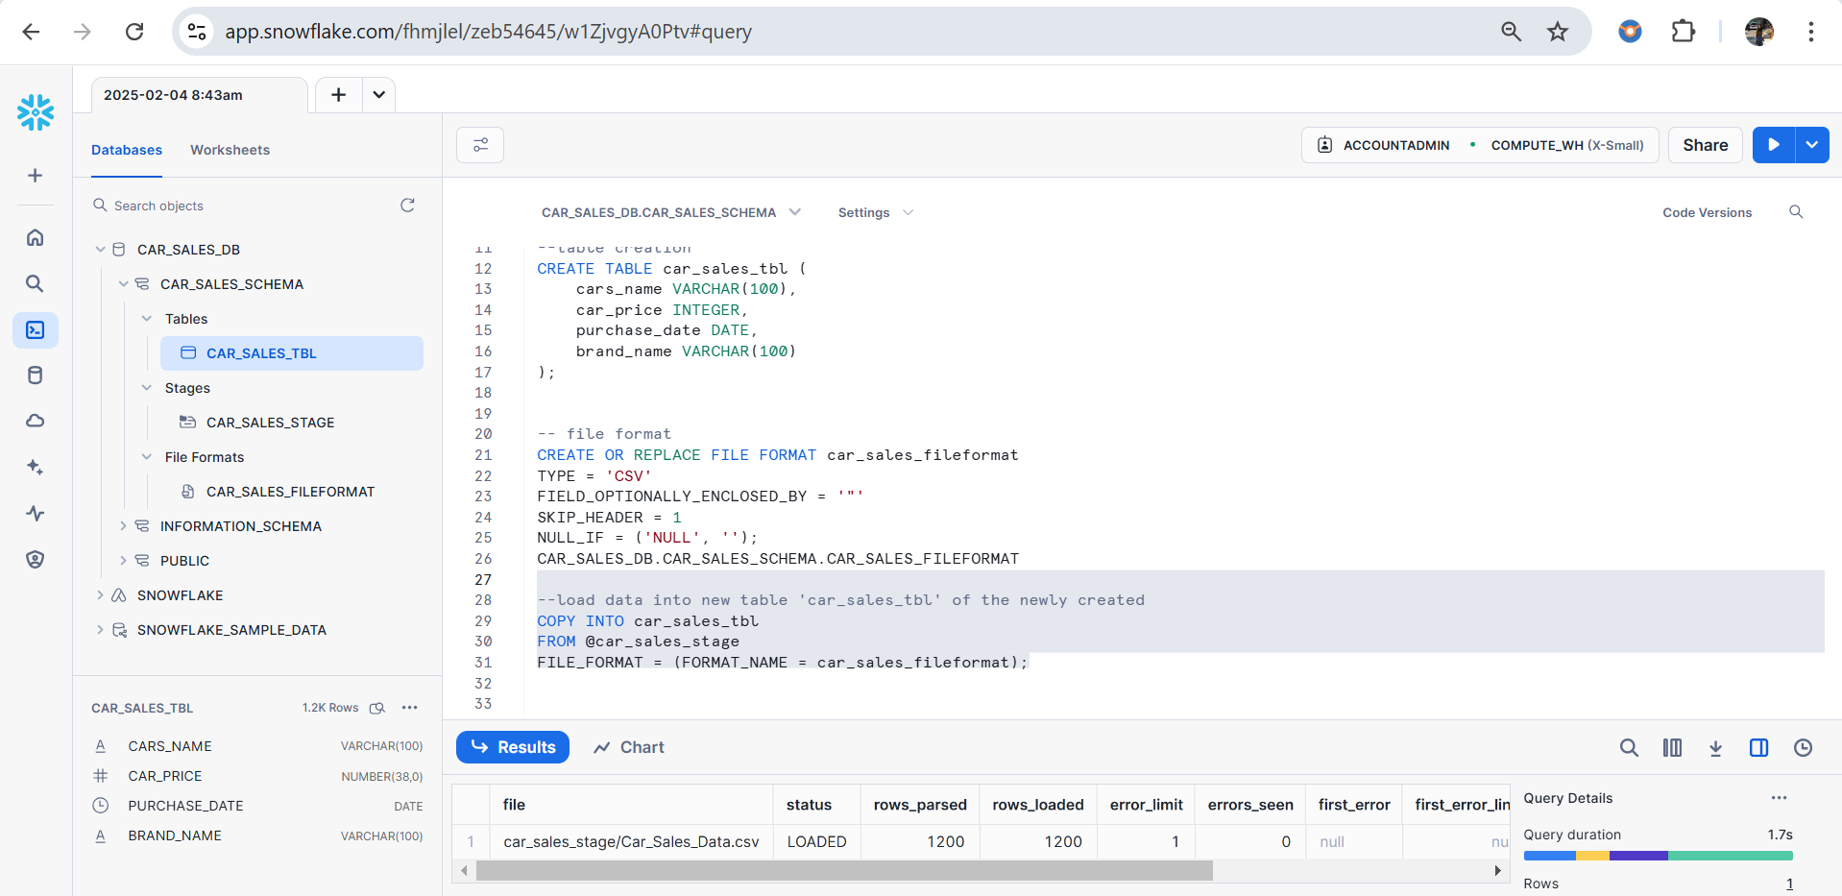
CODE:
COPY INTO car_sales_tbl
FROM @car_sales_stage
FILE_FORMAT = (FORMAT_NAME = car_sales_fileformat);

5. Write an SQL queries for each that shows the following insights

- The average number of cars sold per month in 2024.
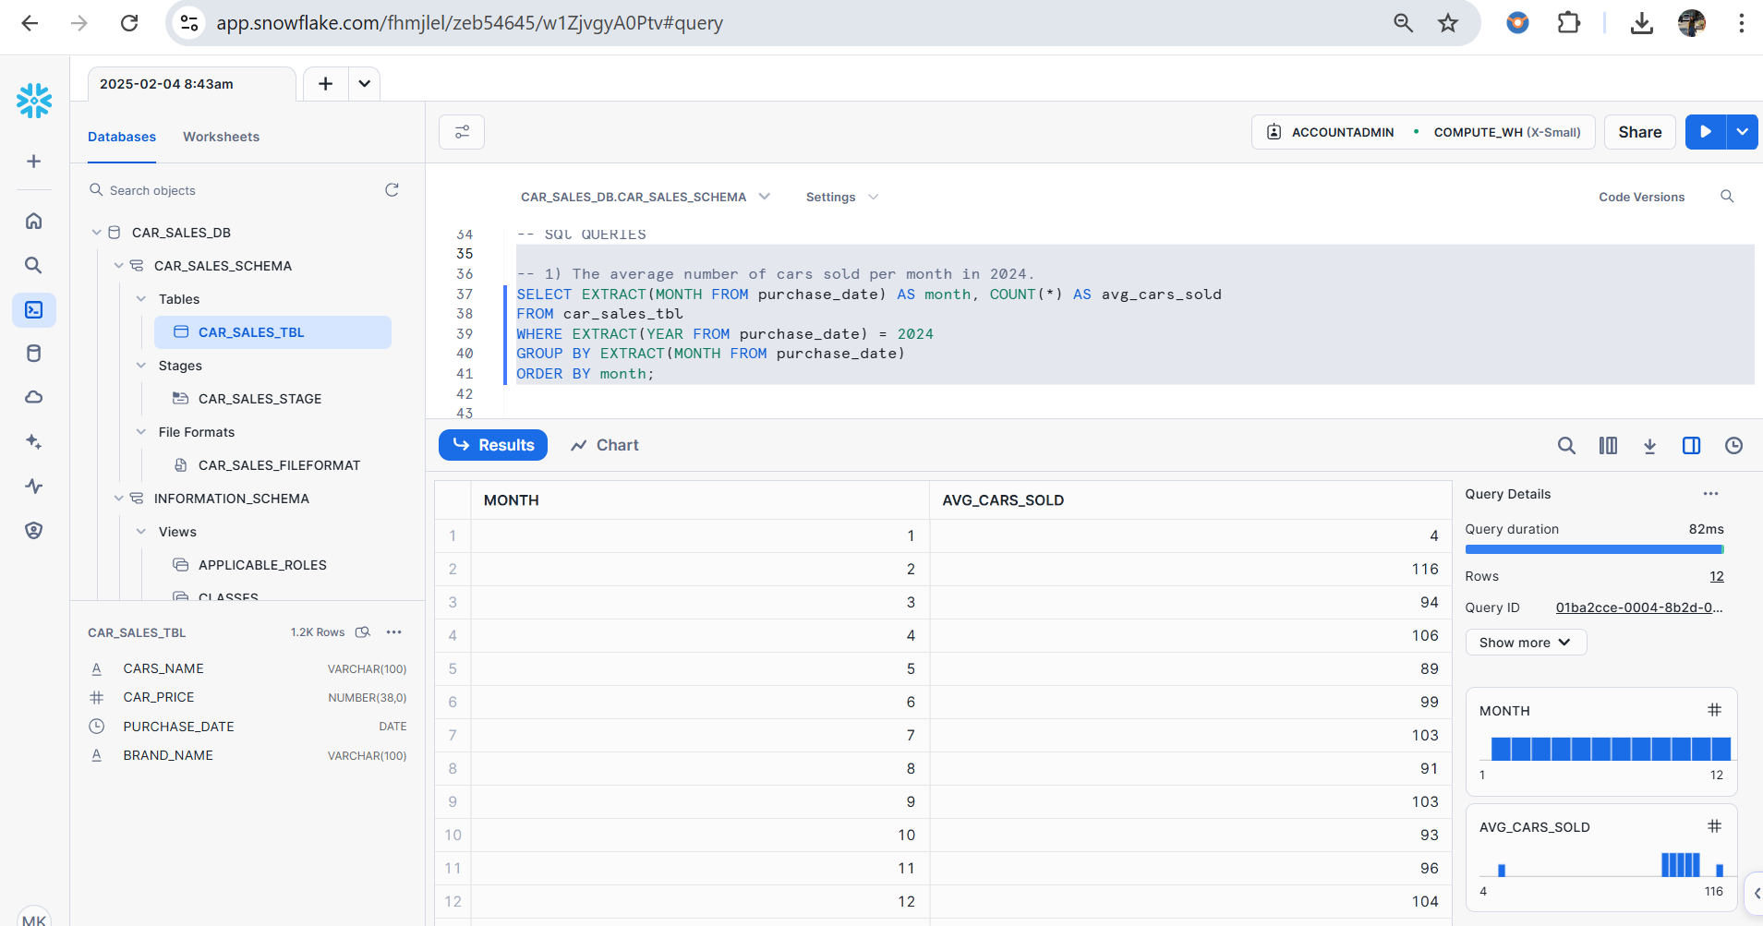
CODE:
SELECT EXTRACT(MONTH FROM purchase_date) AS month, COUNT(*) AS avg_cars_sold
FROM car_sales_tbl
WHERE EXTRACT(YEAR FROM purchase_date) = 2024
GROUP BY EXTRACT(MONTH FROM purchase_date)
ORDER BY month;

2) The top 5 best-selling cars along with the count in 2024.
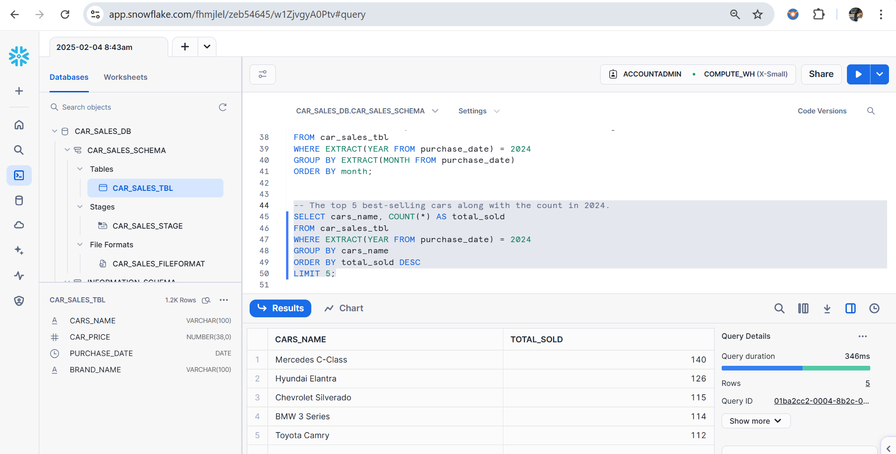
CODE:
SELECT cars_name, COUNT(*) AS total_sold
FROM car_sales_tbl
WHERE EXTRACT(YEAR FROM purchase_date) = 2024
GROUP BY cars_name
ORDER BY total_sold DESC
LIMIT 5;

3) The top 3 least-selling cars along with the count in 2024.

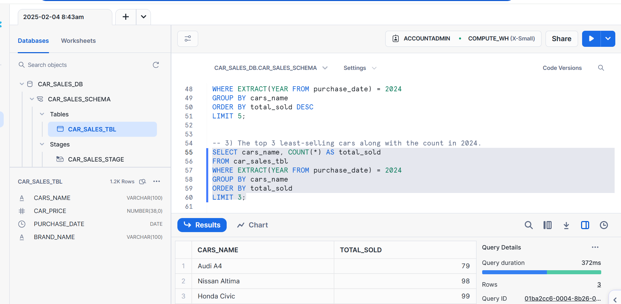
CODE:
SELECT cars_name, COUNT(*) AS total_sold
FROM car_sales_tbl
WHERE EXTRACT(YEAR FROM purchase_date) = 2024
GROUP BY cars_name
ORDER BY total_sold
LIMIT 3;

